EDUCATION
LANGUAGES

SEPTEMBER 2005–MAY 2010
High School Diploma
FIRST LANGUAGE HIGH SCHOOL, VARNA (BG) OCTOBER 2010–JUNE 2013
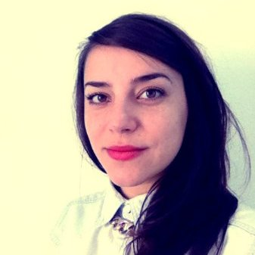
Bachelor’s Degree in International Relations UNIVERSITY OF BIRMINGHAM, BIRMINGHAM, (UK) SEPTEMBER 2013–JUNE 2014
Master’s Degree in International Relations and European Studies CENTRAL EUROPEAN UNIVERSITY, BUDAPEST (HU)

WORK EXPERIENCE
BULGARIAN Native ENGLISH
Full professional proficiency
FRENCH
Full professional proficiency

SKILLS

NAME SURNAME

DATE OF BIRTH
24.10.1991
ADDRESS
66 Andrey Lyapchev Bld.,
Sofia, Bulgaria
E-MAIL mariya.v.lazarova@gmail.com PHONE
+359 887 994958
November 2014 - Present
Customer support
SOFICA GROUP JSC
October 2012 - October 2014
Research Assistant
INSTITUTE FOR CONFLICT, COOPERATION AND SECURITY Research work
August 2012 - September 2012
Trainee
EUROPEAN PARLIAMENT
Research work

VOLUNTEER WORK

March 2012 – July 2014
BULGARIAN FOOD BANK Organizational tasks; contacting vendors/resellers March 2013 - June 2013
SOFIA DESIGN WEEK; EDNO
MAGAZINE
Helping with the organization of the biggest design gathering in Bulgaria; contacting speakers, sponsors, partners, officials.
ADOBE PHOTOSHOP ADOBE ILLUSTRATOR ADOBE INDESIGN MICROSOFT OFFICE

INTERESTS

PHOTOGRAPHY TYPOGRAPHY MUSIC
MOVIES TRAVEL

